**Excel Assignment – 6**

**Q1. What are the various elements of the Excel interface? Describe how they're used.**

**Ans:** The Excel interface consists of various elements, each serving a specific purpose. Here is a brief description of each element:

1. Ribbon: The ribbon is located at the top of the Excel window and contains tabs, groups, and commands that are used to perform tasks in Excel. Each tab contains a set of related commands organized into groups.
2. Quick Access Toolbar: This is a customizable toolbar that is located above or below the ribbon. It allows you to add frequently used commands for easy access.
3. Workbook: A workbook is a collection of one or more worksheets. By default, each workbook contains three worksheets, but you can add or delete worksheets as needed.
4. Worksheet: A worksheet is a grid of cells that contains data or formulas. Each worksheet is identified by a sheet tab located at the bottom of the Excel window.
5. Cell: A cell is a rectangular box located at the intersection of a row and a column. It is used to store data or formulas.
6. Name Box: The name box is located next to the formula bar and displays the name or address of the selected cell or range.
7. Formula Bar: The formula bar is located above the worksheet area and displays the contents of the active cell, including any formulas or functions.
8. Status Bar: The status bar is located at the bottom of the Excel window and displays information about the current worksheet, such as the sum of selected cells or the status of the caps lock key.
9. Scroll Bars: The scroll bars are located on the right and bottom of the worksheet area and allow you to scroll through the worksheet to view different parts of the data.
10. Zoom Slider: The zoom slider is located on the status bar and allows you to zoom in or out of the worksheet to make it easier to view or edit.

These are the main elements of the Excel interface, each playing a vital role in creating, editing, and analyzing data in Excel.

**Q2. Write down the various applications of Excel in the industry.**

**Ans:** Excel is a widely used software in various industries due to its ability to efficiently manage and analyze data. Here are some of the applications of Excel in different industries:

1. Finance: Excel is extensively used in the finance industry to create financial models, perform complex financial analysis, track budget and expenses, and create financial reports.
2. Accounting: Excel is used by accountants to manage and analyze financial data, create budgets and forecasts, track expenses, and prepare financial statements.
3. Marketing: Excel is used in the marketing industry to manage and analyze customer data, track sales and marketing campaigns, and perform market research and analysis.
4. Human Resources: Excel is used in the HR industry to manage and track employee data, create employee schedules, and prepare payroll reports.
5. Education: Excel is used in the education industry to manage and analyze student data, track grades, and create lesson plans.
6. Healthcare: Excel is used in the healthcare industry to manage patient data, track medical expenses, and create medical reports.
7. Manufacturing: Excel is used in the manufacturing industry to manage inventory, track production, and analyze production data.
8. Real Estate: Excel is used in the real estate industry to manage property listings, track sales and rental income, and create financial reports.

**Q3. On the ribbon, make a new tab. Add some different groups, insert commands in the groups and name them according to their commands added. Copy and paste the screenshot of the steps you followed.**

**Ans:** Below steps are followed to add some different groups, insert commands in the groups and name.

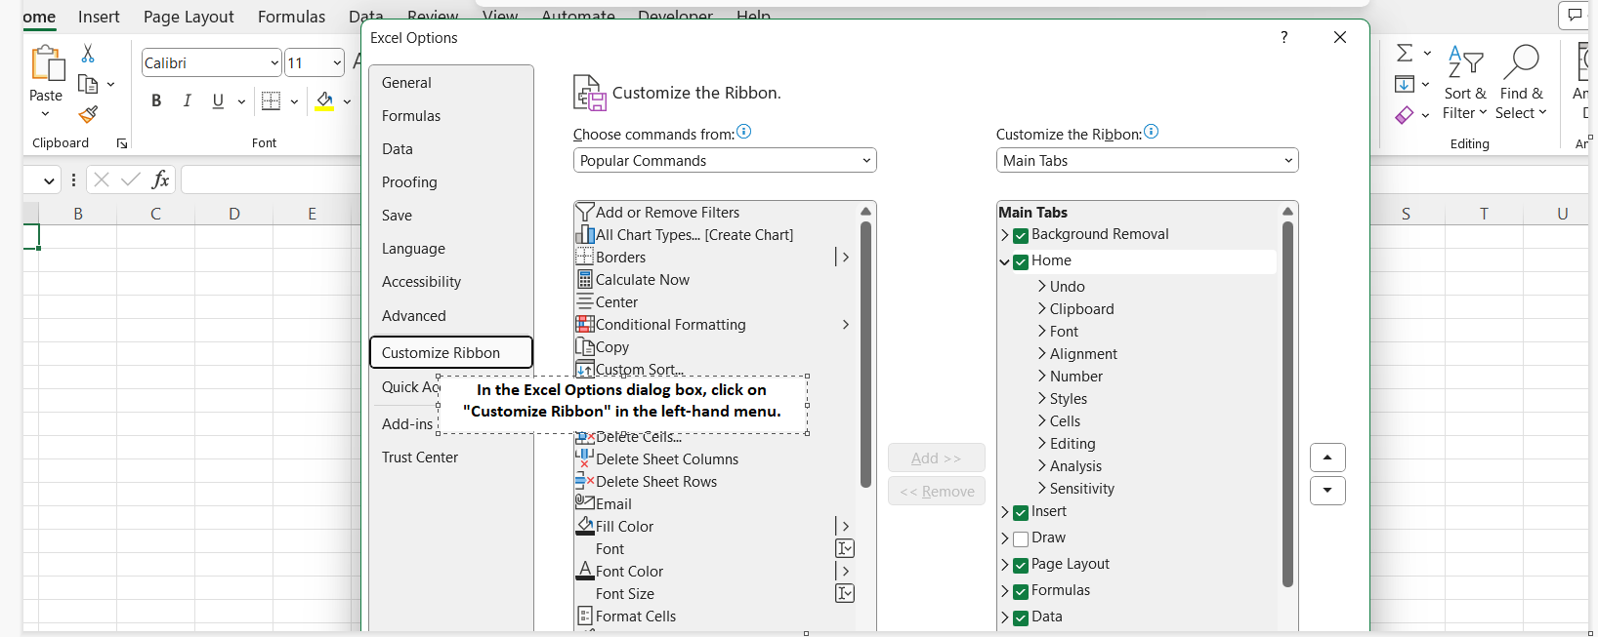

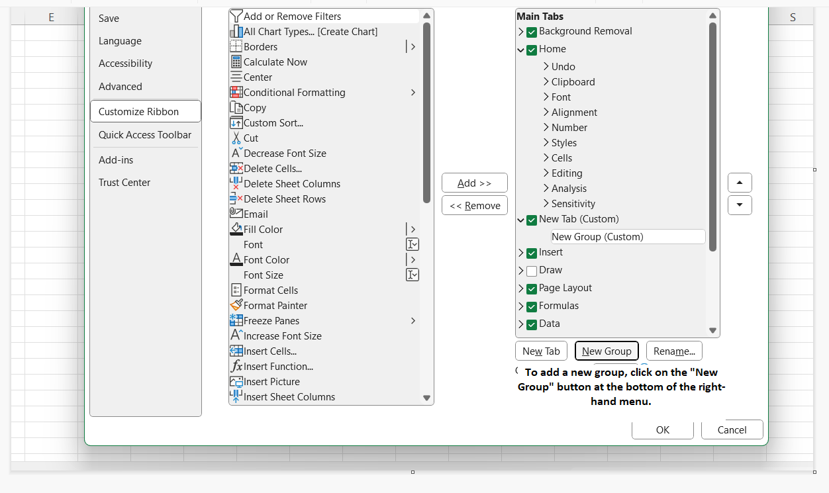

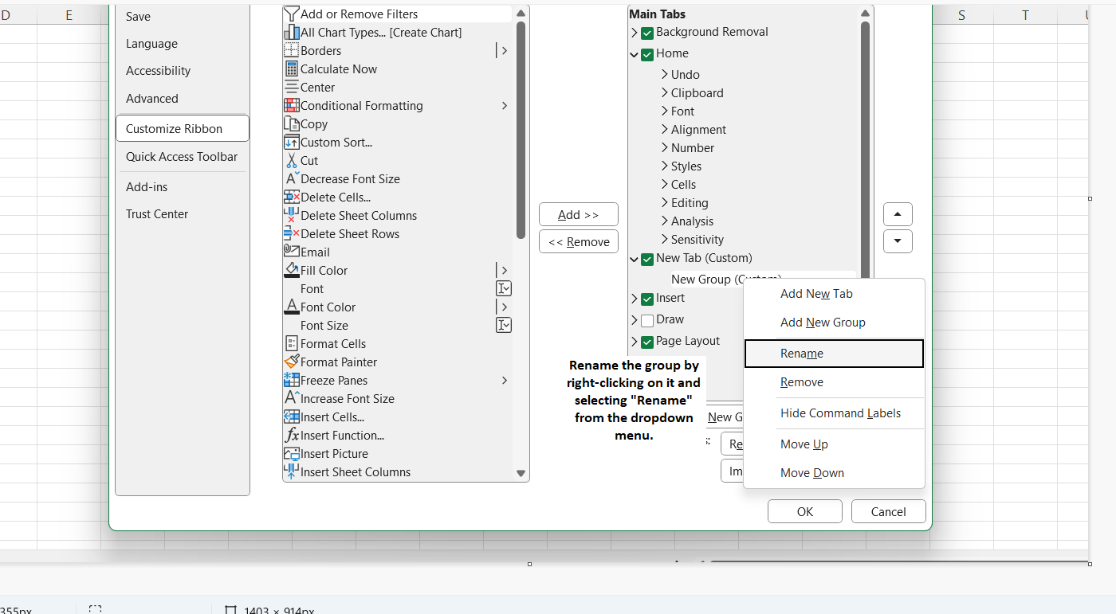

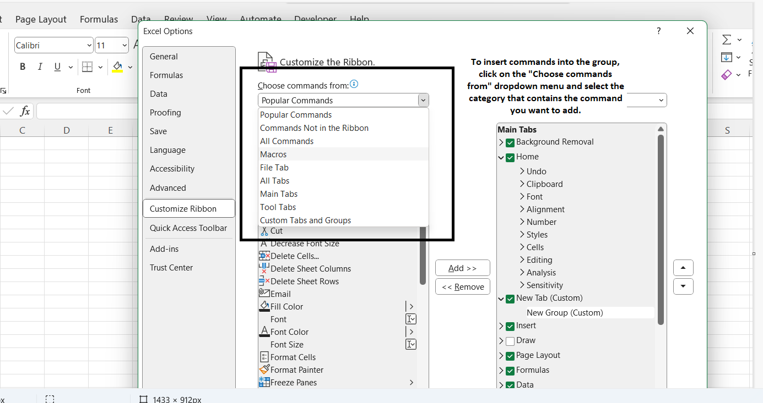

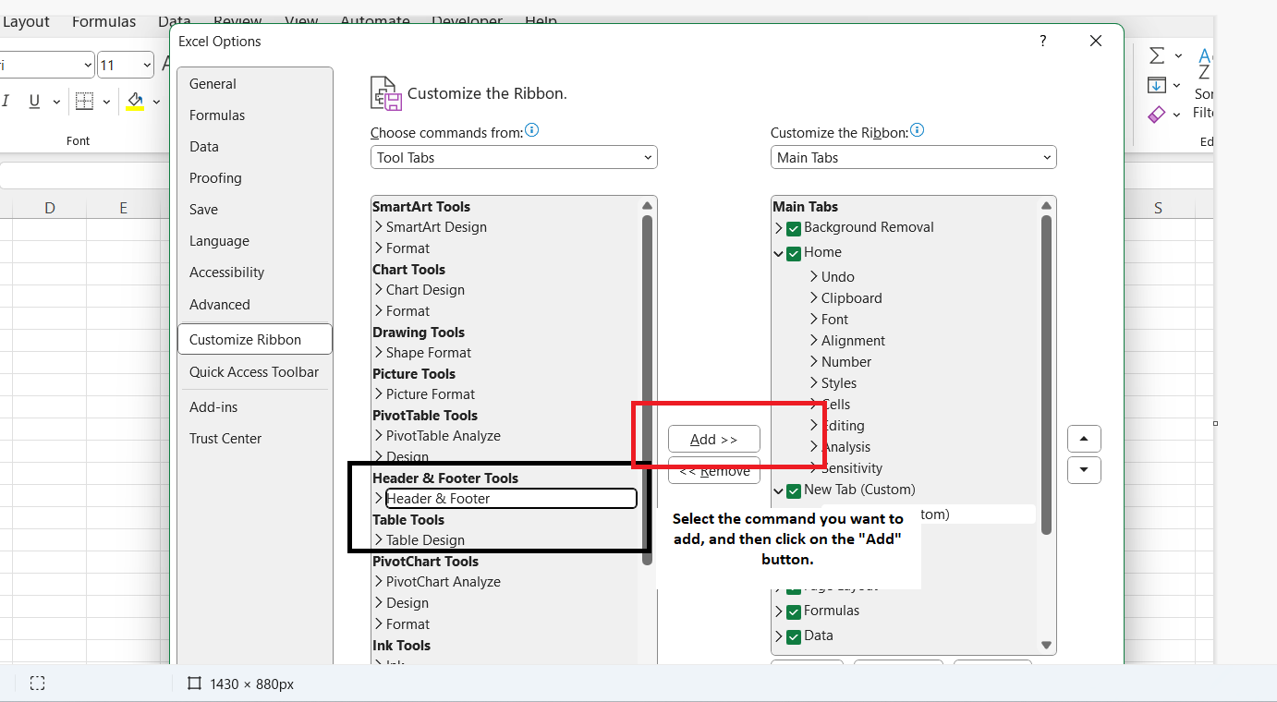

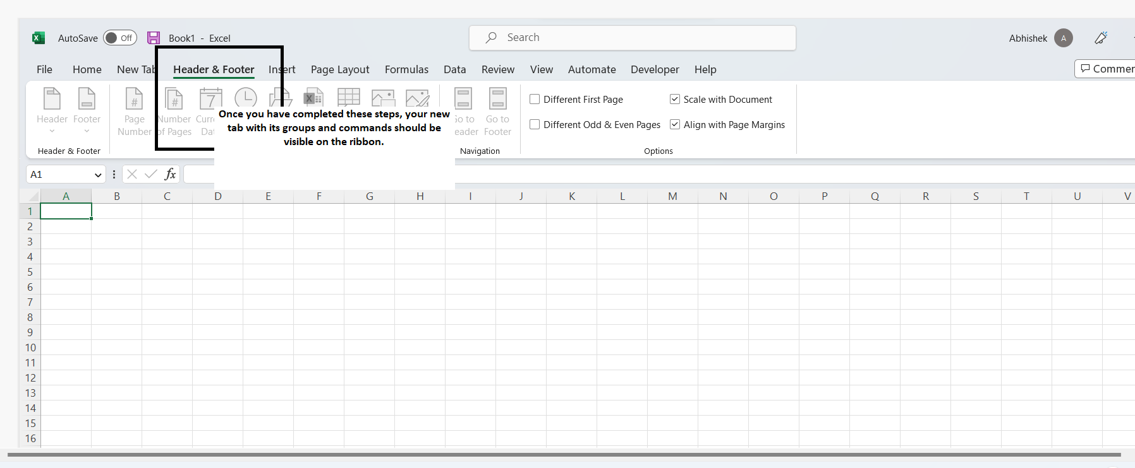

**Q4. Make a list of different shortcut keys that are only connected to formatting with their functions.**

**Ans:** Here is a list of some commonly used shortcut keys in Excel that are only connected to formatting with their functions:

1. Ctrl + 1: Open the Format Cells dialog box.
2. Ctrl + Shift + $: Apply the Currency format to the selected cells.
3. Ctrl + Shift + #: Apply the Date format to the selected cells.
4. Ctrl + Shift + %: Apply the Percent format to the selected cells.
5. Ctrl + Shift + &: Apply the Border format to the selected cells.
6. Ctrl + B: Apply or remove Bold formatting from the selected cells.
7. Ctrl + I: Apply or remove Italic formatting from the selected cells.
8. Ctrl + U: Apply or remove Underline formatting from the selected cells.
9. Ctrl + 9: Hide the selected rows.
10. Ctrl + 0: Hide the selected columns.
11. Alt + H, H: Set the cell format to "General".
12. Alt + H, 0: Set the cell format to "Number".
13. Alt + H, E, A: Clear all formatting from the selected cells.

**Q5. What distinguishes Excel from other analytical tools?**

**Ans:** Excel has several features that distinguish it from other analytical tools, including:

1. User-friendliness: Excel is one of the most user-friendly analytical tools available. Its interface is easy to navigate, and it offers a wide range of features that are easy to use.
2. Versatility: Excel is a versatile tool that can be used for a wide range of tasks, from simple calculations to complex data analysis.
3. Familiarity: Excel is a widely used tool, and many people are familiar with it. This makes it easy to share data and collaborate with others.
4. Customizability: Excel allows users to customize their workbooks to suit their specific needs. Users can create custom formulas, macros, and pivot tables to analyze data in a way that works best for them.
5. Accessibility: Excel is a widely available tool that can be accessed on almost any computer. This makes it easy for users to work on their data from anywhere, as long as they have access to the software.
6. Integration: Excel can be integrated with other analytical tools, such as Power BI and Tableau, to create more powerful data analysis solutions.

**Q6. Create a table and add a custom header and footer to your table.**

**Ans:** Below is the table with the HR_EMPLOYEE Attribution as a Header and Page 1 as a Footer.

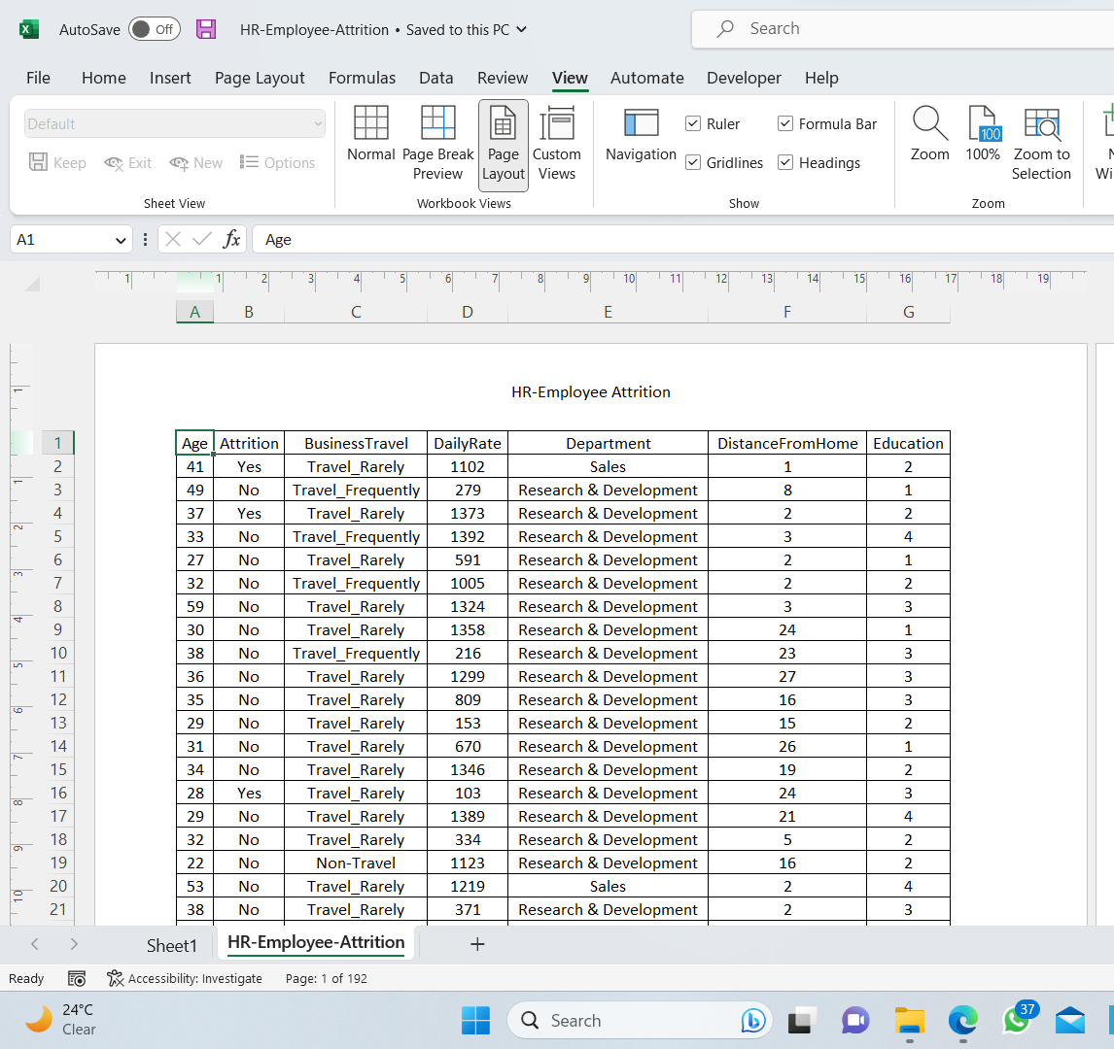

**HEADER**

**FOOTER**